# CSCE 121: Final Project

The following paper demonstrates the design process for the development and implementation of the material learned in Introduction to Program Design and Concepts.

## **Team information**

**Team name**: “Pancake Pro”

**Team members**:

* Gerardo Vazquez
* Will Tallent
* Yuan Yao

**Assignments**:

In our first meeting, we assigned tasks. Gerardo Vazquez was assigned the scoreboard and free store functions such as collecting the users nickname and calculating the score. Will Tallent was assigned the buttons and callbacks; this means, Will was assigned the splash screen, instructions, and different windows throughout the game. Lastly, Yuan Yao was assigned the pancake algorithm to generate graphical objects and a function to sort them as desired by the user.

## **Problem Definition**

The assignment specified is to design a program using C++11 and the FLTK graphical user interface to implement a pancake sorting game. The main challenge is the create a stack of pancakes of unique sizes and let the user sort them in order from largest on the bottom to smallest on top until it is in order.

**Constraints**:

The most significant restriction was time. The limited availability to met was in shortage due to personal schedules proving it to be the most significant constraint. Furthermore, the lack of experience from our team required research and the use of functions not yet covered at the time implemented in our source code.

**Approach**:

Our strategy consisted in starting small and continually implement code segments until a functional program was achieved. Our top priority was to get the pancake stack creating individual objects for each flipping them accordingly and concluding the project having a graphical game.

## **Program**

The program works using the files provided by Dr. Daugherity as parents for our Base_screen, find_solution, Game_screen, Pancake, PancakeStack, Record, Scoreboard, and Splash_screen source and header files.

**Screenshots**:

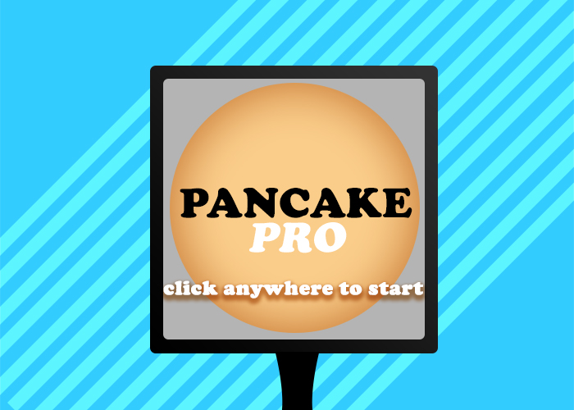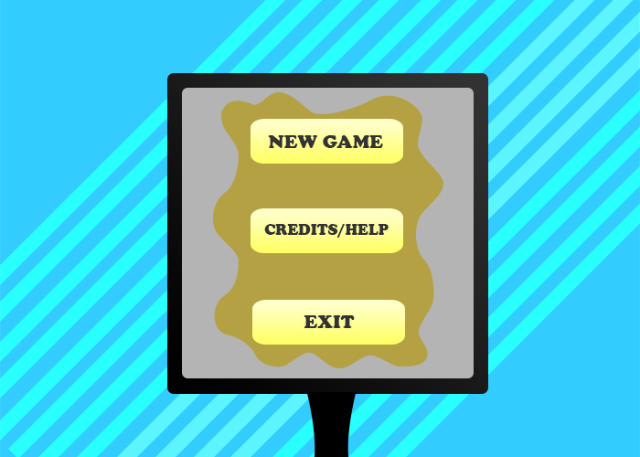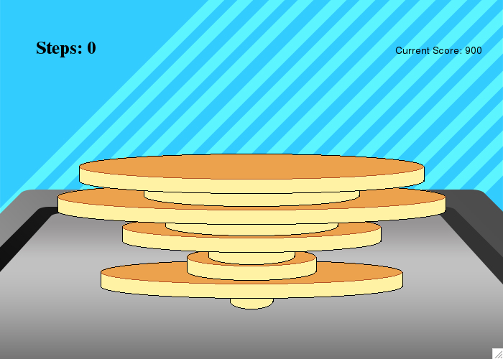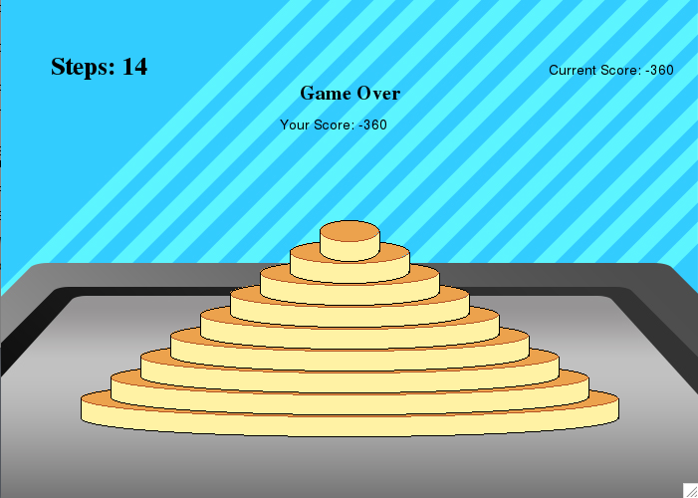

**Results and Analysis**:

The resulting program is practical in functionality. The core of the program evolves around the PancakeStack source code. In it the pancake shape objects are created and shuffled using recursion to check it’s order. The main program transitions between windows and will conclude once the exit bottom is selected.

**Conclusion**:

The project was completed successfully on time as required in the specification. Initially, Yuan Yao took the lead implementing the pancake stack and sorting algorithm. We are convinced we worked as a team in good faith, but unfortunately the tasks planned shifted as Yuan completed the project with no trouble. The team learned the basic functions of the FLTK library, several standard template functions, and the implementation of callbacks.

**Improvements**:

The program could be improved by using formatted buttons to match the style of the game instead of overlapping them with an image. Furthermore, the algorithm used to create a vector of pancakes could be more efficient using less cycles and less memory to achieve the same results.

**Instructions**:

1. Click anywhere in the splash screen
2. Select new game, instructions, or exit.
3. If new game is clicked, input username and level.
4. Click on the pancake you want to flip. Clicking on the pancake will rotate that pancake and the pancakes above it.
5. The game will conclude once the pancakes are stacked in order starting from the bottom from largest to smallest using the least flips possible.

**Source Code:**

## Bibliography